**Project Report — Digital Ecosystem (DES)**

**Fetching and Displaying JSON Data via a Python API**  
**Project:** Streetwear JSON API  
**Members:** Sekou, Dikra & Joelle

**1. Introduction**

The goal of this project is to manipulate JSON data using a Python script, by accessing an API hosted on GitHub Pages. We chose the theme of a streetwear brand to create a custom JSON file containing multiple items with detailed characteristics.

The objective was to apply the skills learned in class regarding fetching, parsing, and displaying data through HTTP requests using Python.

**2. Project Description**

We created a JSON file (streetwear_data.json) containing 3 objects representing streetwear items. Each object includes:

* A name
* A description
* A set of technical specifications (size, color, material, etc.)
* Tags related to the item

This file is hosted on GitHub Pages, making it accessible via a public URL.

**3. Technical Implementation**

**3.1 File Structure**

* streetwear_data.json: JSON file containing the data
* fetch_data.py: Python script that fetches and displays the JSON data
* README.md: project documentation

**3.2 Python Script Functionality**

The script uses the requests library to send a GET request to the JSON file URL. After retrieving the content, it converts it into Python objects using the .json() method.

The data is then iterated through to display each item clearly in the console. An error handling system alerts the user in case of connection issues or invalid data.

**4. Steps Completed**

* Creation of the JSON file
* Hosting the file on GitHub Pages
* Developing the Python script to fetch and display the data
* Implementing error handling in the script
* Setting up a public GitHub repository with the project structure
* Writing the README to explain how to use the project
* Preparing the oral presentation

**5. Challenges Encountered**

* Initial Git repository setup and remote configuration
* Enabling and configuring GitHub Pages to host the JSON file
* Handling network errors in Python
* Understanding the JSON structure for parsing

**6. Results and Demonstration**

When running the script, the JSON data is correctly fetched and displayed. Below is an excerpt of the output in the terminal:

yaml

CopierModifier

Name: Sneakers UrbanX

Description: Comfortable sneakers, perfect for city wear.

Specifications:

- Color: Black

- Size: 42

- Material: Synthetic leather

Tags: shoes, urban, comfort

The JSON file is publicly accessible at:  
<https://sekou2oo4.github.io/streetwear-json-project/streetwear_data.json>

**7. Conclusion**

This project allowed us to apply concepts related to JSON data manipulation, using APIs with Python, and hosting files via GitHub Pages.

It also made us aware of the importance of error handling and clear code structure.

Finally, this collaborative work strengthened our skills in Git and technical presentations.

**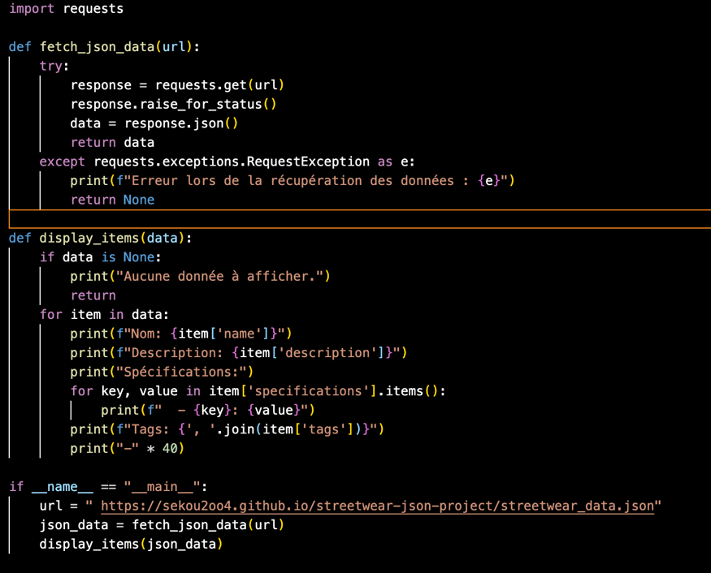Annexes**